# CS 255 System Design Document Template

This template lays out all the different sections that you need to complete for Project Two. Each section has guidance to prompt your thinking. You will need to continually reference the interview transcript as you work to make sure that you are addressing your client’s needs. There is no required length for the final document. Instead the goal is to complete each section based on what your client’s needs are. Remove this note when you are finished, and replace all bracketed text with the relevant information.

## UML Diagrams

### UML Use Case Diagram

### UML Activity Diagrams

### UML Sequence Diagram

### UML Class Diagram

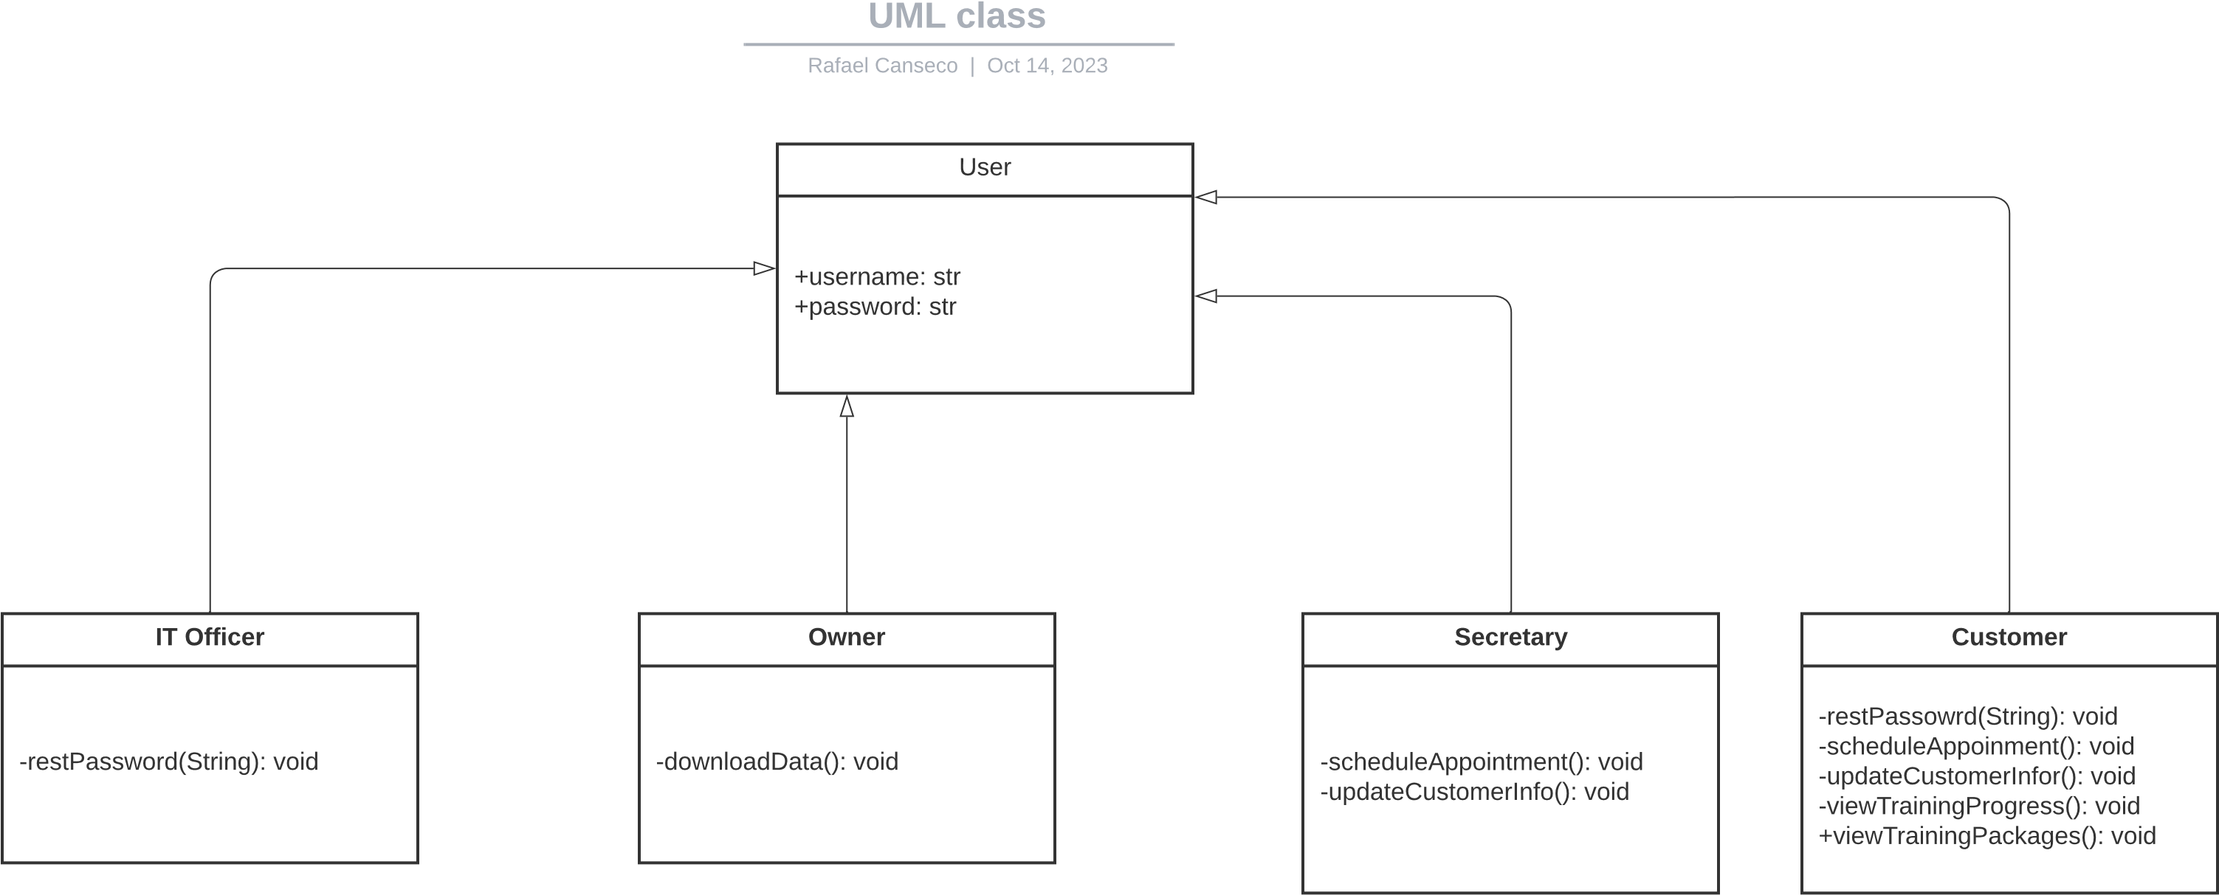

## Technical Requirements

Our system entails specific technical requirements. It must be web-based, hosted in the cloud, and include a mobile version for on-the-go data access by the owner. To store critical information, we require a database, which could be cloud-based or located in a physical data center, for managing login credentials and other essential data. To ensure the security and integrity of data, all data transfers, both between users and within the organization, will be encrypted using SSL (Secure Sockets Layer). Utilizing a cloud platform will facilitate real-time updates, such as the training calendar for appointment scheduling and user training progress tracking. Additionally, role-based access control will be implemented, enabling different privileges for various user roles, such as the owner, IT officer, secretary, and customers, to perform specific actions as needed.